1:PASSPORT MANAGEMENT SYSTEM

USE CASE DIAGRAM:

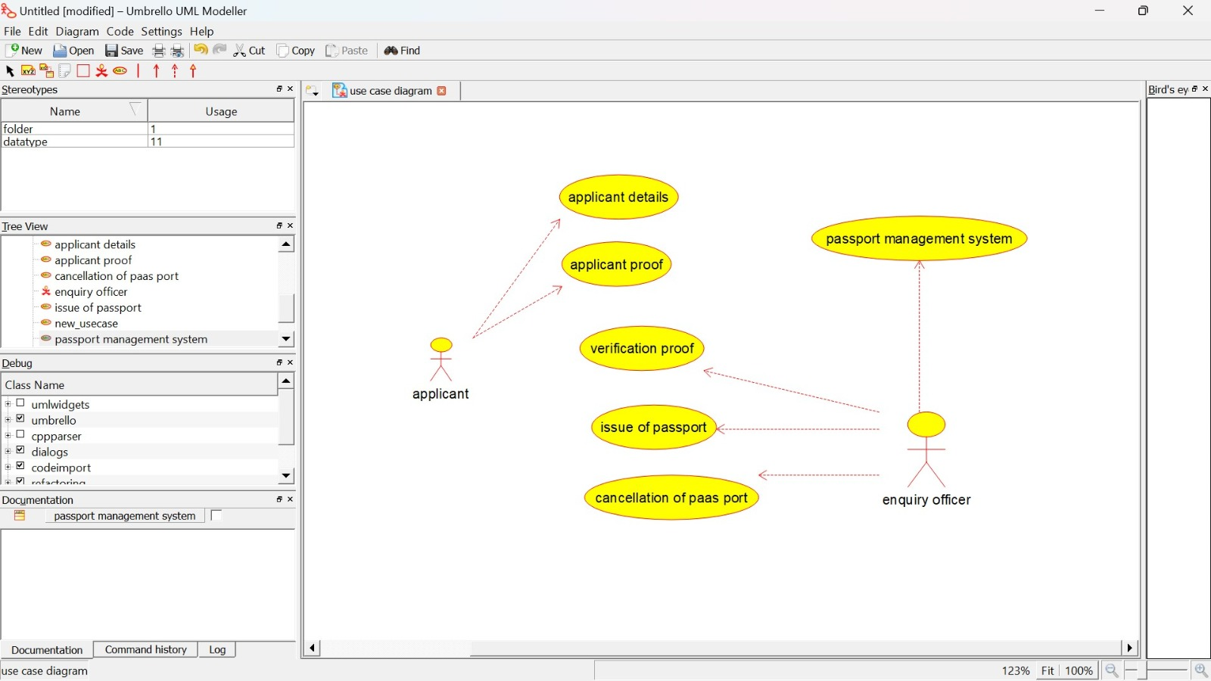

CLASS DIAGRAM:

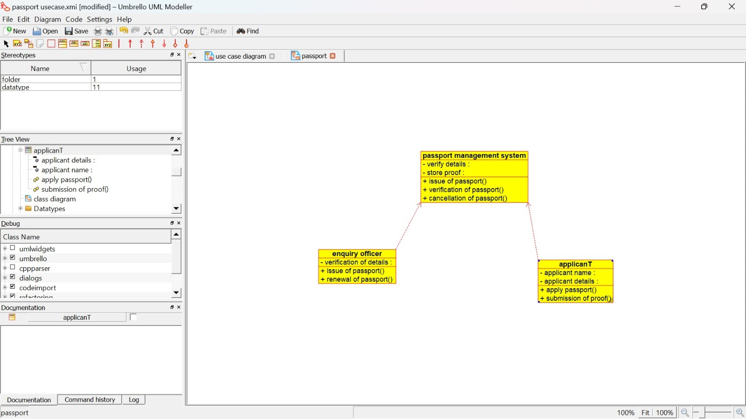

ACTIVITY DIAGRAM:

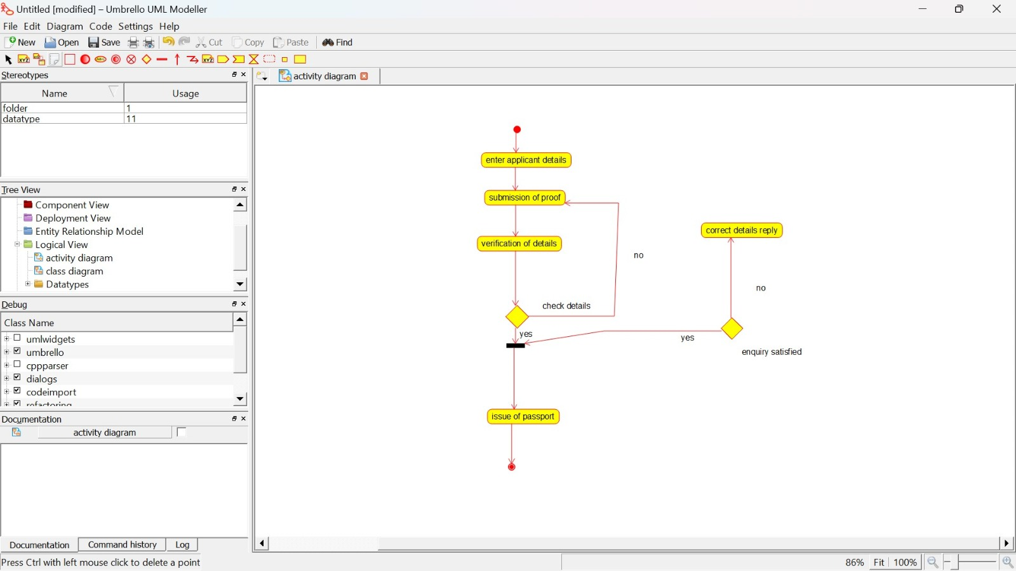

SEQUENCE DIAGRAM:

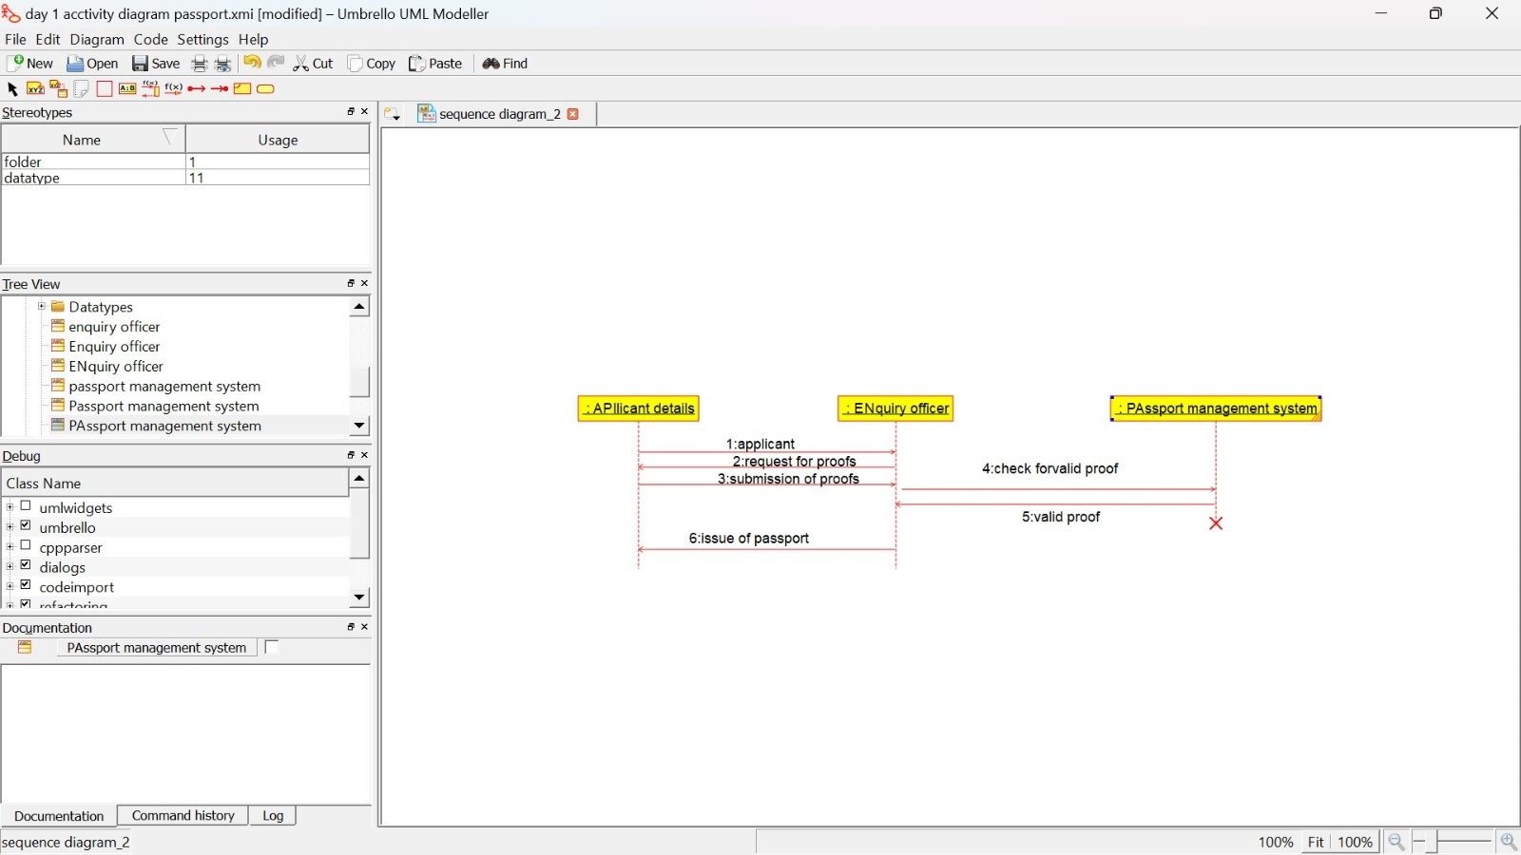

COLLABORATION DIAGRAM:

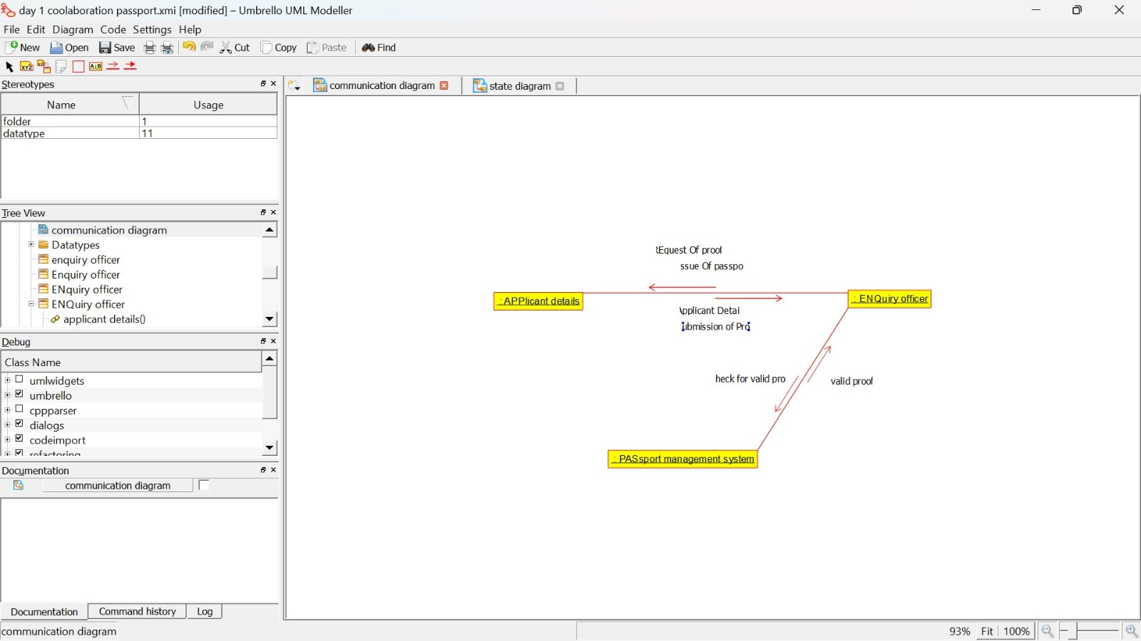

STATE CHART DIAGRAM:

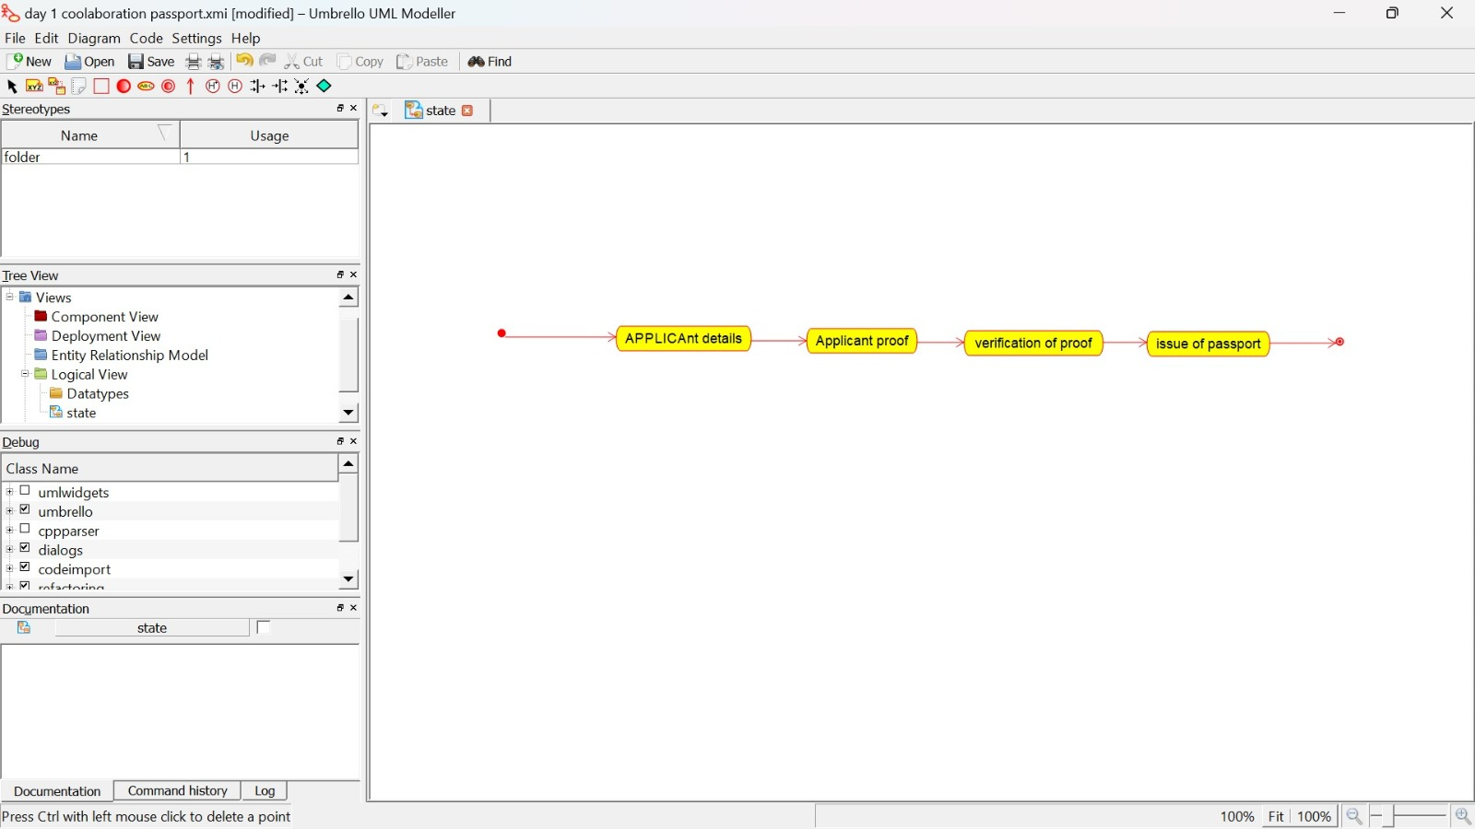

COMPONENT DIAGRAM:

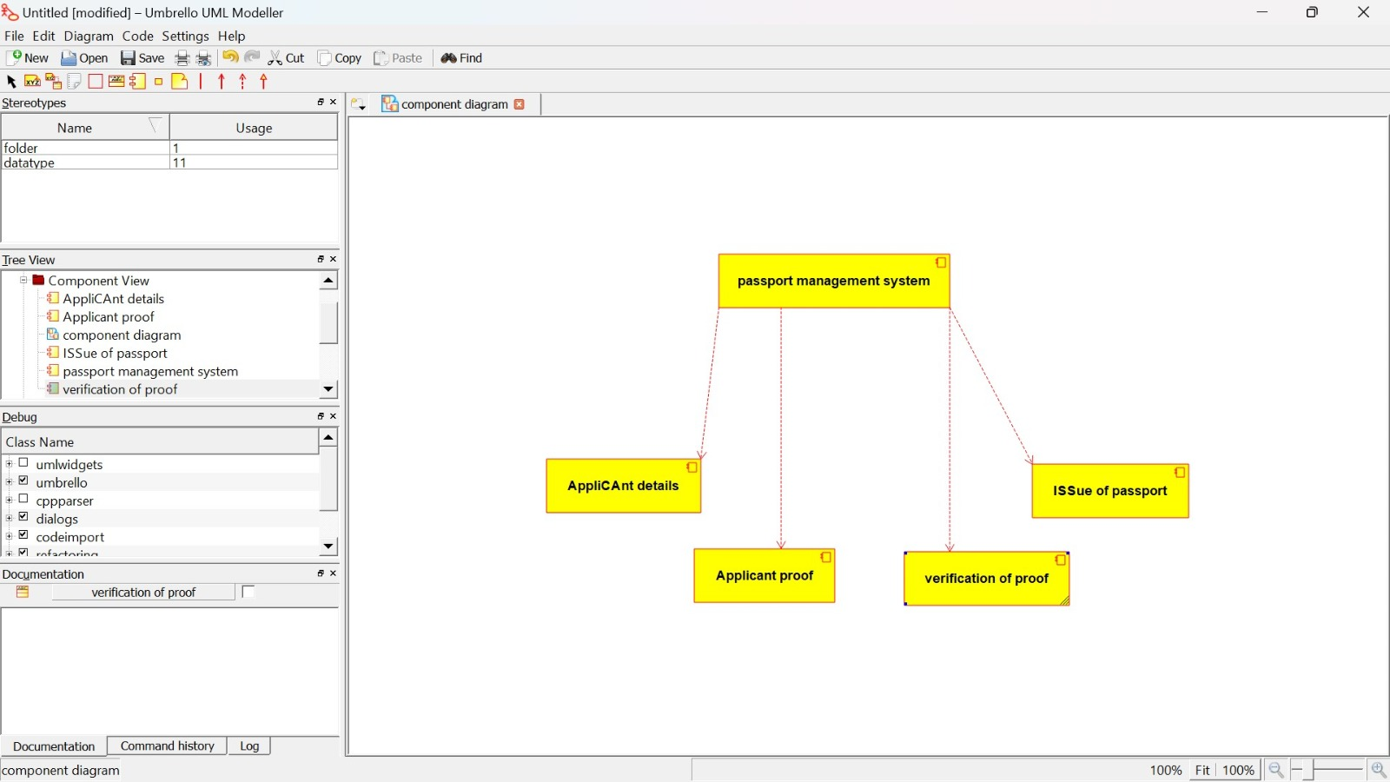

DEPLOYMENT DIAGRAM:’

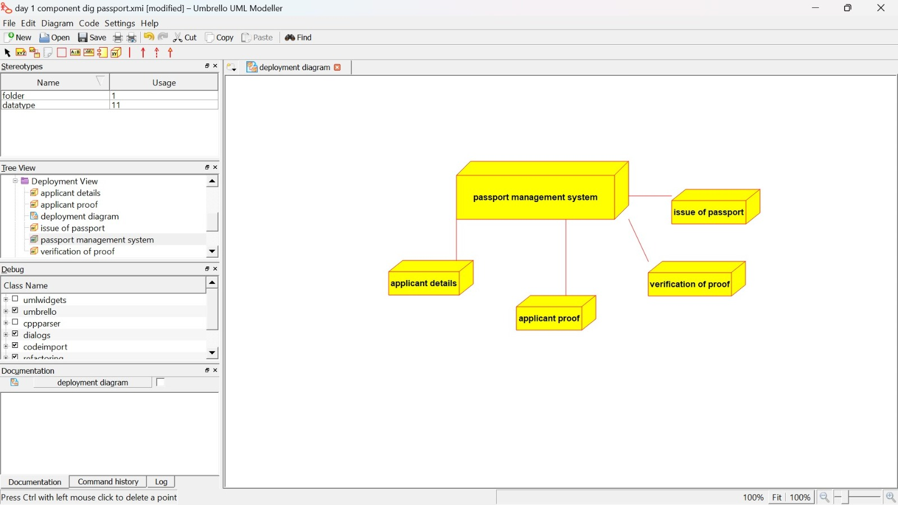

PACKAGE DIAGRAM:

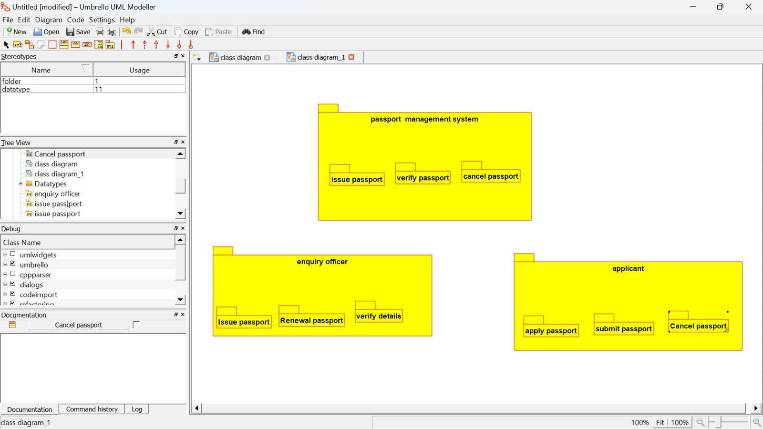

PROGRAM:

**APPLICANT:**

Public class Applicant

{

Public Integer firstname;

Public Integer lastname;

Public void passport()

{

}

}

**PASSPORT APPLICATION SYSTEM:**

Public class passport application system

{

Public Integer details;

Public Integer proof;

Public class Applicant

{

Public Integer firstname;

Public Integer lastname;

Public void passport()

{

}

Public void verification()

{

}

Public void issue()

{

}

Public void cancel()

{

}

}

**OFFICER:**

Public class officer

{

Public Integer form;

Public Integer responsible;

Public void Database()

{

}

}

2:BOOK BANK REGISTRATION SYSTEM

USE CASE DIAGRAM:

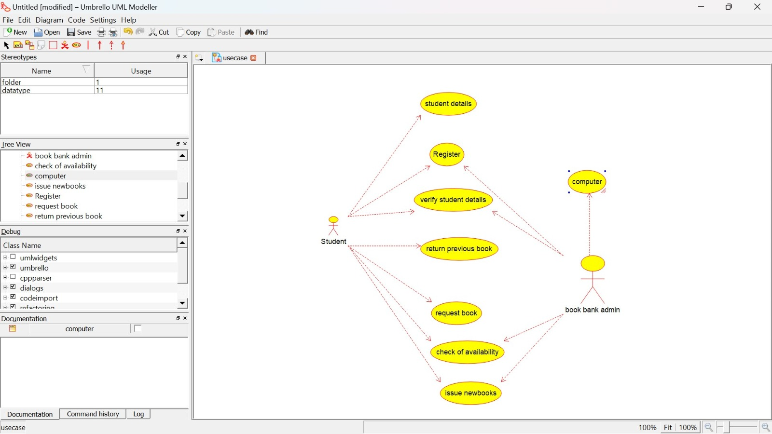

CLASS DIAGRAM:

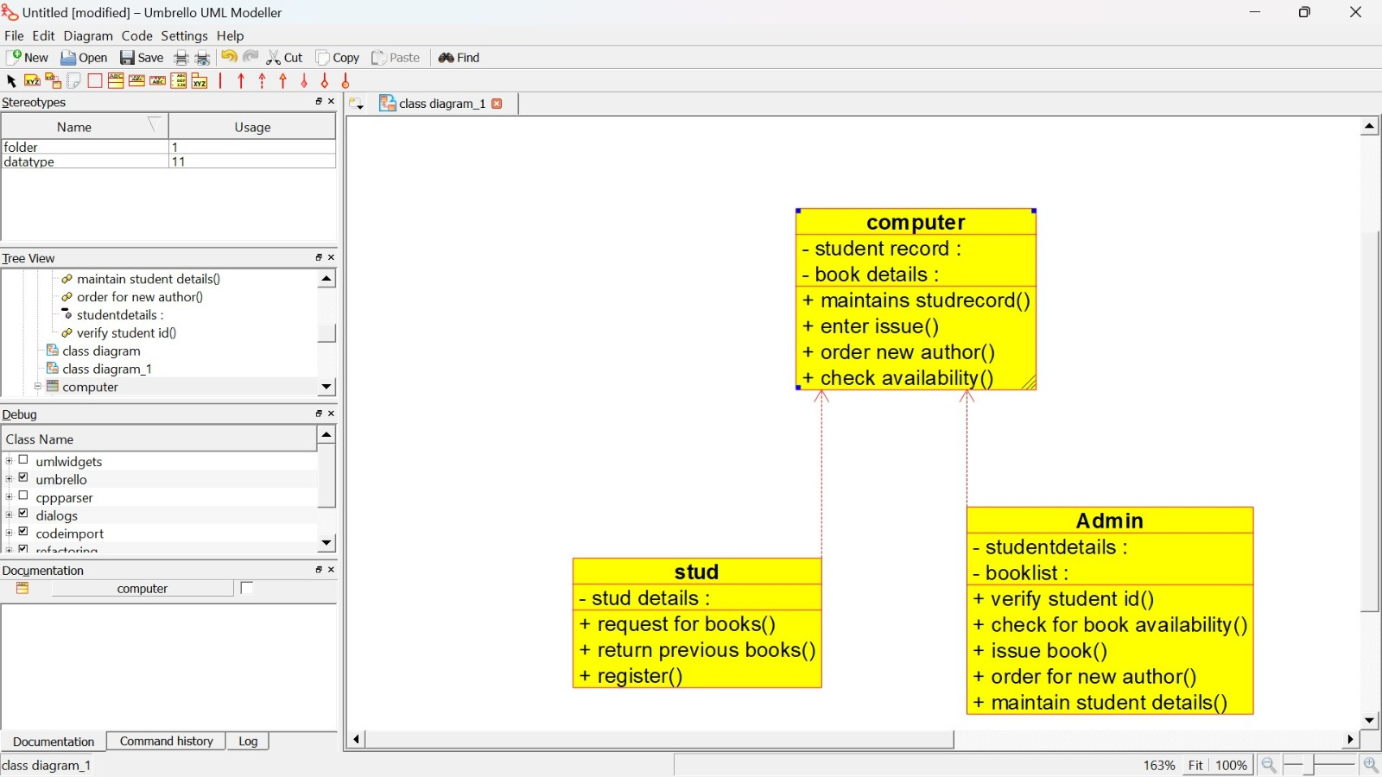

ACTIVITY DIAGRAM:

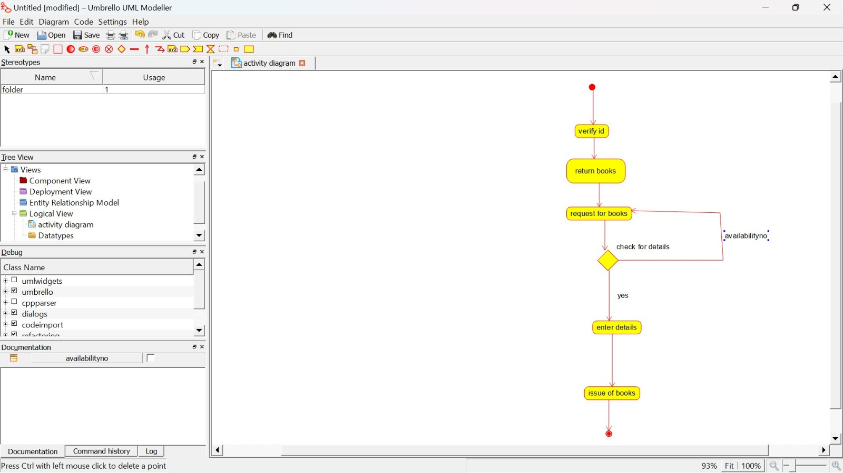

SEQUENCE DIAGRAM:

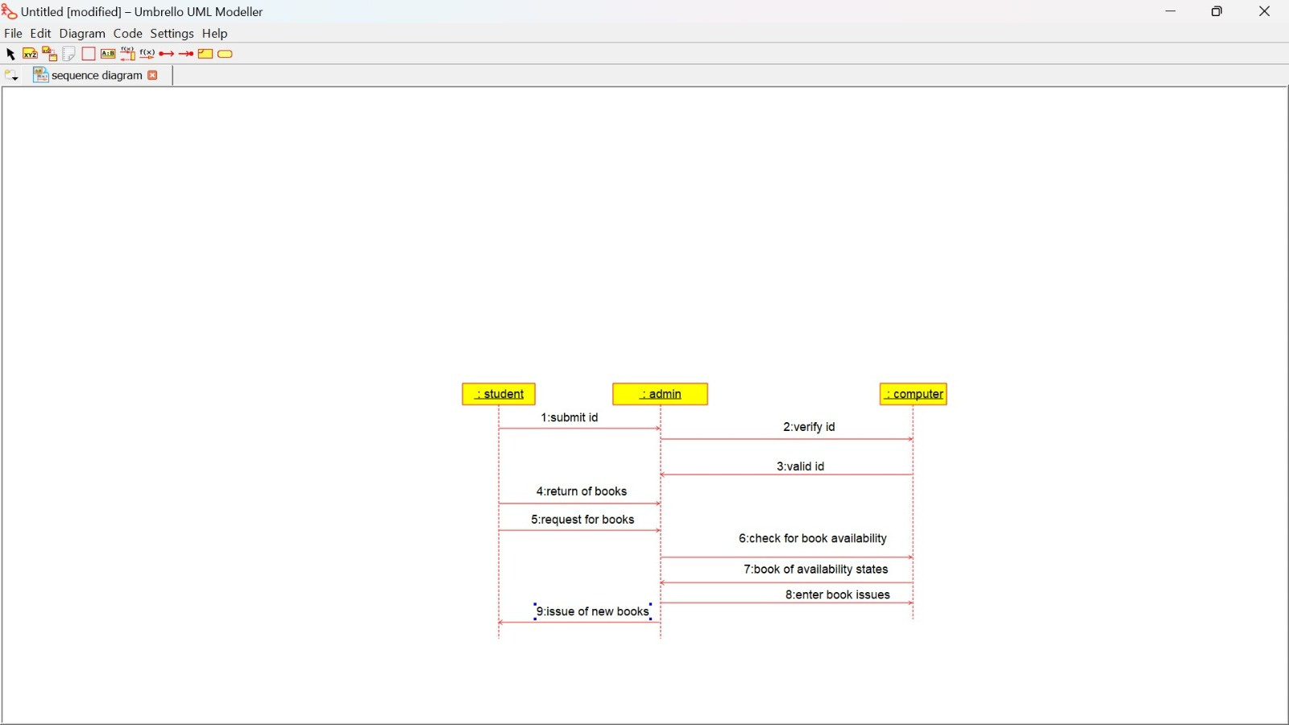

COLLABORATION DIAGRAM:

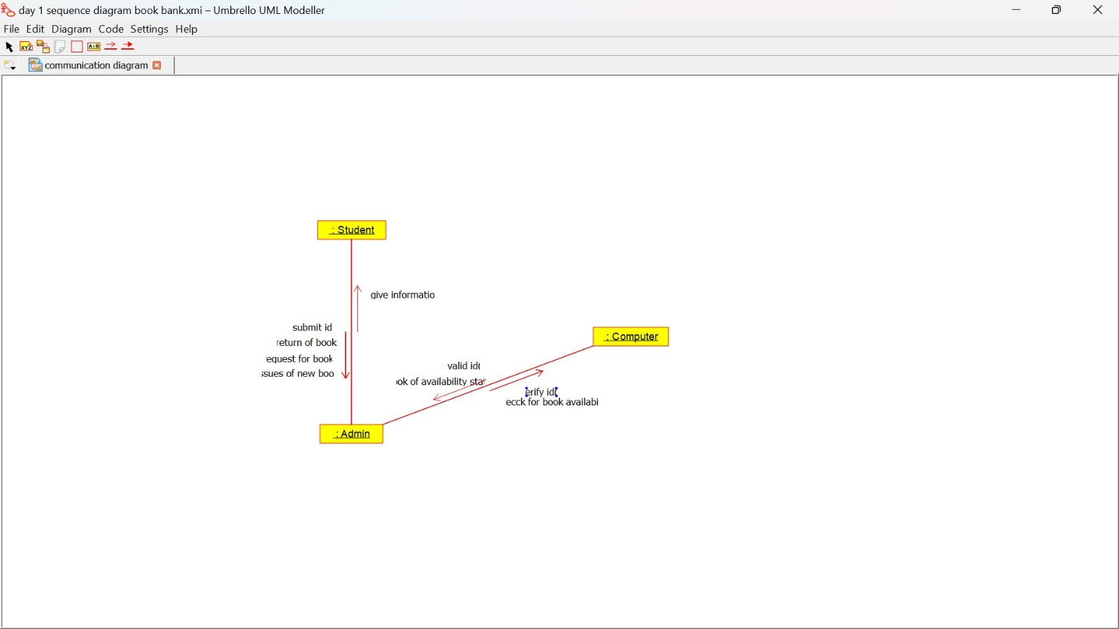

STATE CHART DIAGRAM:

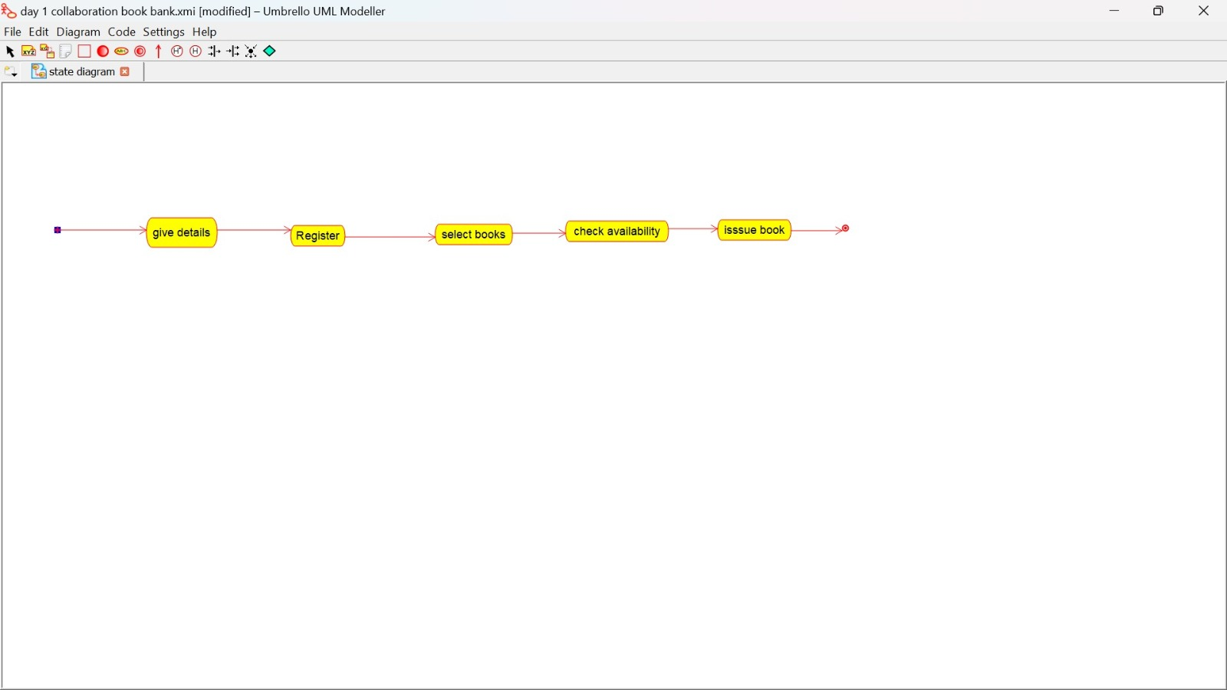

COMPONENT DIAGRAM:

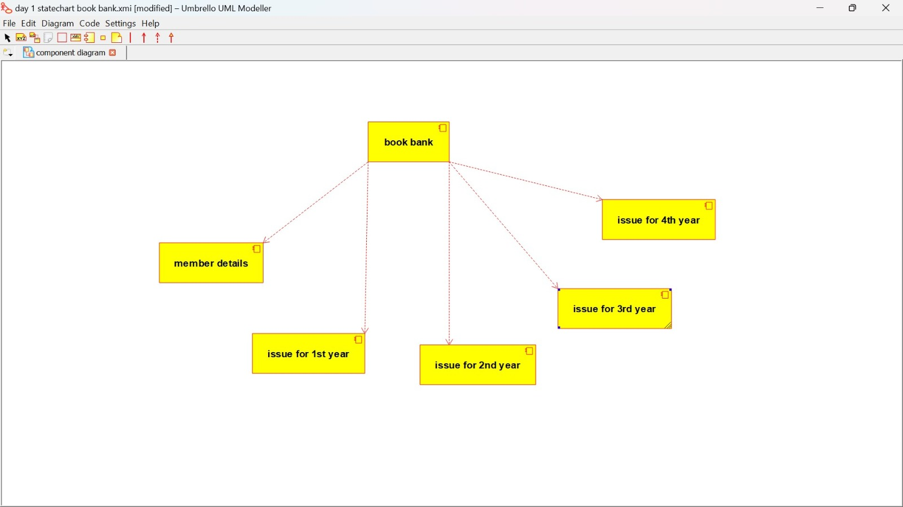

DEPLOYMENT DIAGRAM:

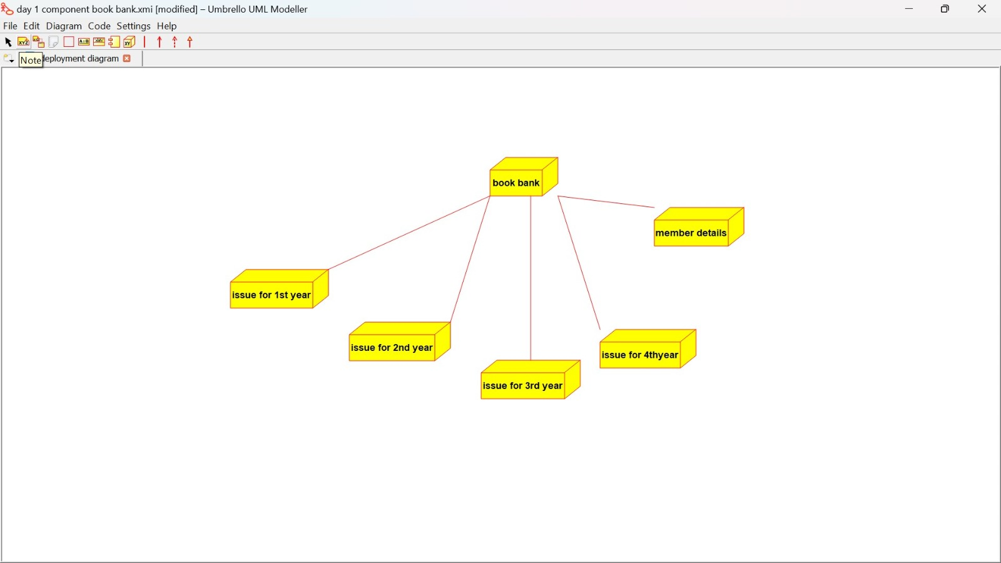

PACKAGE DIAGRAM:

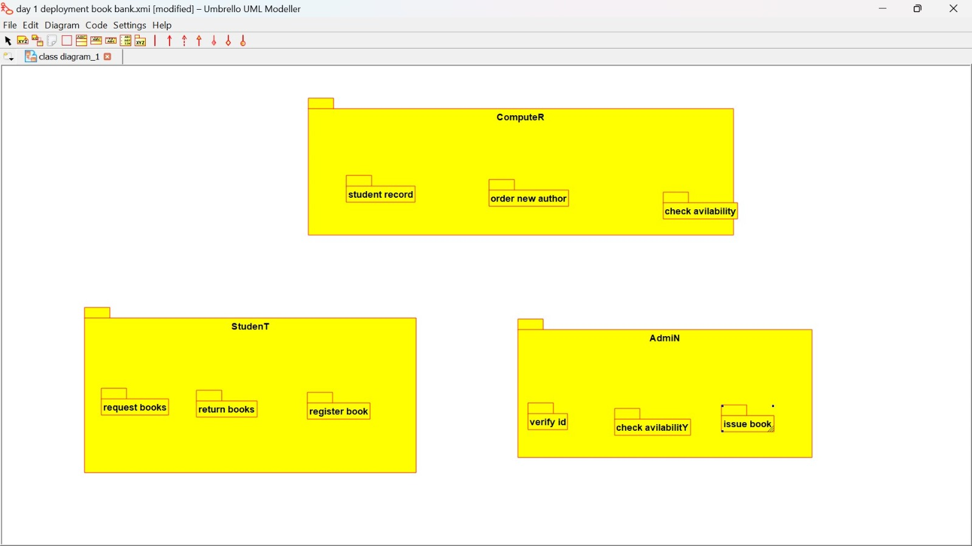

PROGRAM:

**ADMIN:**

Public class admin

{

Public integer student details;

Public integer book list;

Public void verify stud id()

{

}

Public void check for availability()

{

}

Public void issue books()

{

}

Public void order for new author()

{

}

Public void maintains stud details()

{

}

}

**STUDENT:**

Public class stud

{

Public integer studdetails;

Public void request for books()

{

}

Public void register()

{

}

**COMPUTER:**

Public class computer

{

Public integer stud record;

Public integer booklist;

Public void maintain stud rec()

{

}

Public void enter issue()

{

}

Public void order new author()

{

}

Public void check availability()

{

}

}